**Ideation Phase**

**Define the Problem Statements**

|  |  |
| --- | --- |
| Date | 25 June 2025 |
| Team ID | LTVIP2025TMID59501 |
| Project Name | ResolveNow |
| Maximum Marks | 2 Marks |

**Customer Problem Statement Template:**

To define the core problems freelancers face while searching for jobs online, and use those insights to guide the development of Freelance Finder.

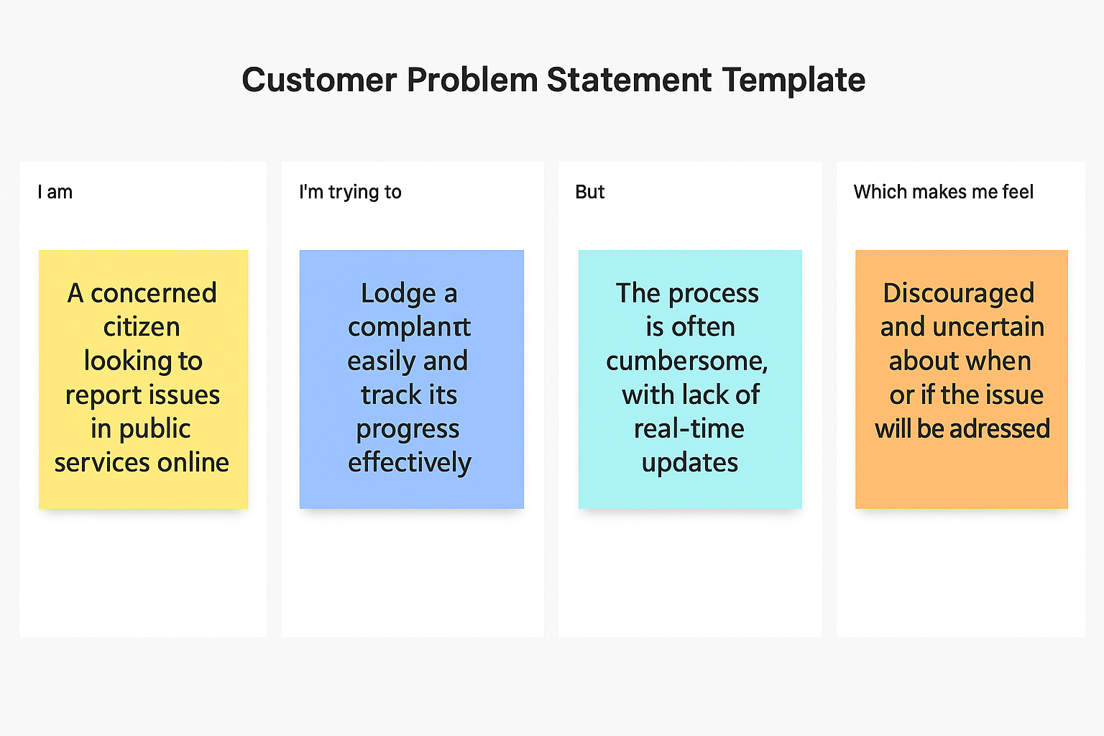

|  |  |  |  |  |  |
| --- | --- | --- | --- | --- | --- |
| **Problem Statement (PS)** | **I am (Customer)** | **I’m trying to** | **But** | **Because** | **Which makes me feel** |
| PS-1 | a citizen facing issues with public services. | register and track my complaint online without visiting the office. | there is no centralized or user-friendly system to submit and monitor complaints | the existing process is manual, slow, and lacks transparency | frustrated, unheard, and uncertain about when or if my issue will be resolved. |
| PS-2 | |  | | --- | | a complaint handling officer in a public or private organization. |      |  | | --- | |  | | manage and resolve complaints efficiently based on their category and urgency. | complaints are received from different channels and tracked manually. | the current system is not streamlined and lacks intelligent assignment features. | overwhelmed and unable to respond to issues in a timely manner. |